Word Search Puzzle Solver in Java)

Introduction
Word Search puzzles are a popular form of entertainment that require players to find hidden words in a grid of letters. These puzzles help improve vocabulary, spelling, and pattern recognition skills. Developing a program to solve such puzzles involves searching for words efficiently in a matrix, which is both a practical and academic challenge.
The task is to automate the search for particular words in a provided letter grid. The words can be read in forward or backward in horizontal, vertical, or diagonal directions.This problem involves designing an efficient algorithm that can perform fast searches across a two-dimensional array while managing multiple directions of movement.

Overview of Features

The system will support:
- Fast lookup of valid words using HashSet.
- Search across 8 possible directions (horizontal, vertical, diagonal).
- Highlighting found words visually on the board.
- Timer functionality to challenge players.
- Hint system to assist users.
- Undo/redo features for incorrect selections.
- Scalable design to accommodate larger puzzles and more words.

Literature Review

Word search solvers have been approached using techniques like brute-force, depth-first search (DFS), and optimized structures such as Trie trees for prefix matching. Some systems also utilize multi-threading to speed up search in very large puzzles. However, for a moderate puzzle size, simpler structures like HashSet combined with a DFS approach offer the best balance between speed and simplicity.

Design

The overall design follows a modular and object-oriented approach. The main components include:
- Board: Represents the puzzle matrix.
- WordSearchGame: Handles user interaction, selection, and validation of words.
- Word: Encapsulates a selected word, its start position, and direction.
The program employs a simple DFS-based algorithm to trace possible paths from a given starting point in all eight directions.

Overall Design and Architecture
- Input: Word list and board matrix.
- Process:
  - Store all words in a HashSet for O(1) lookup.
  - For each letter in the grid, search in 8 directions using DFS.
  - Mark valid found words.
- Output: List of successfully found words and updated board with highlights.

Detailed Explanation of Chosen Algorithms and Data Structures
- Depth-First Search (DFS): Used to explore all possible paths from each starting character.
- HashSet: Stores valid words, allowing for O(1) search time for word verification.
- Array: Used for board representation for fast index access.
- List: Stores found words sequentially for displaying results.
DFS is ideal because it allows controlled exploration along each possible direction without unnecessary re-checking.

Justification
- HashSet: Provides O(1) time complexity for checking if a selected word exists.
- Array: Gives quick access to any grid cell without overhead.
- List: Helps in maintaining the order in which words were found.
Alternative data structures like Trie could have been used for prefix matching and better scalability for massive dictionaries, while Graphs could model paths better in dynamic puzzles. However, for static, reasonably sized puzzles, HashSet is the optimal and efficient choice due to its simple usage and constant-time lookup.
UML Diagrams and Sequence Diagram

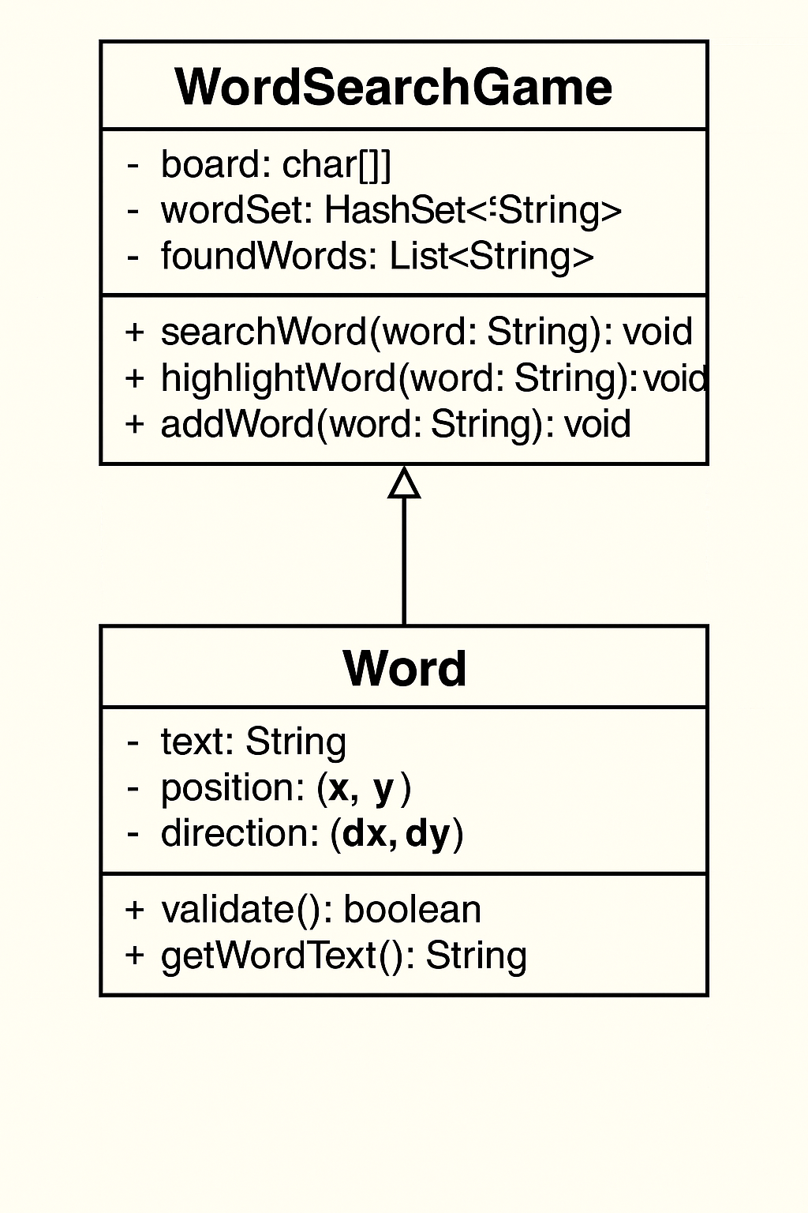

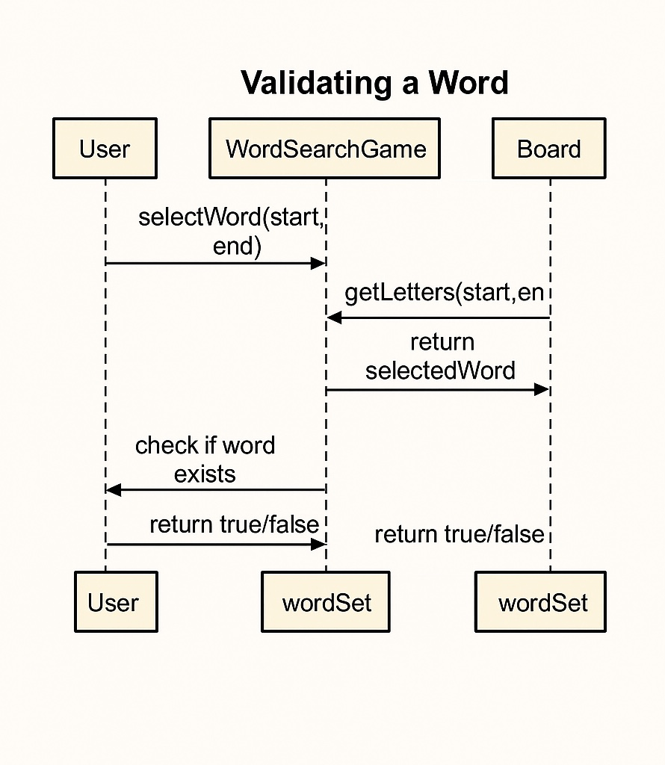

References
- Oracle. (2024). HashSet (Java Platform SE 21). https://docs.oracle.com/en/java/javase/21/docs/api/java.base/java/util/HashSet.html
- GeeksforGeeks. (2024). Depth First Search (DFS) Algorithm. https://www.geeksforgeeks.org/depth-first-search-or-dfs-for-a-graph/
- TutorialsPoint. (2024). Java Collections Framework. https://www.tutorialspoint.com/java/java_collections.htm

